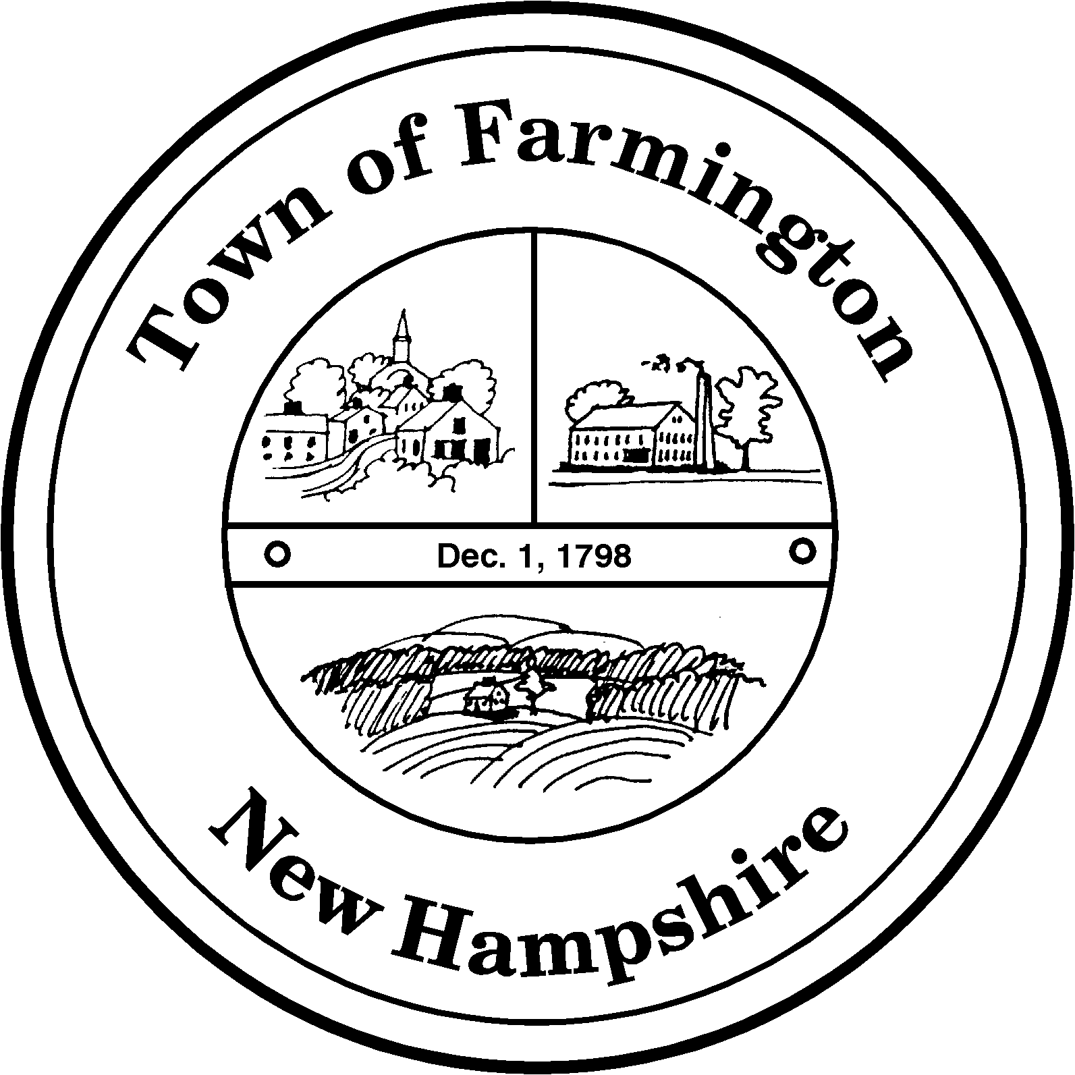
Town of Farmington
Planning and Community Development
356 Main Street
Farmington, NH 03835
Phone: (603) 755-2774
A Bicentennial Community
1798 - 1998

PLANNING BOARD MEETING

Tuesday – January 22, 2013

356 Main Street - Farmington, NH

AGENDA - 6:00 pm

BUSINESS BEFORE THE BOARD:

- Pledge of Allegiance
- Review and approve Meeting Minutes of January 8, 2013
- Any other business to come before the Board

PUBLIC HEARING - 6:30 pm

NEW CASES:

The Farmington Planning Board will hold a second public hearing on proposed zoning amendments on January 22, 2013 at 6:30 p.m. at the Municipal Office Building, 356 Main Street, Farmington. A summary of the proposed zoning amendments is provided below; the full text of the proposed amendments is on file for public inspection at the Farmington Planning Department, Municipal Office Building, 356 Main Street, Farmington.

- To amend Section 1.14 – Definitions to add a definition for Temporary Signs.

- To amend Section 3.09 – Signs to extend the time period during which political signs may be displayed, to clarify standards that apply to temporary signage and signs with messages or graphics that change electronically, and to add language permitting directional signage for agriculture enterprises and standards for said signs.

- To amend Section 3.13 – Manufactured Housing Standards to define manufactured housing, to clarify where manufactured housing units may be located, and to identify standards with which manufactured housing units must comply.

Application for Minor Site Plan Approval By: Lois Munroe, Applicant, Michael Paquette, Property Owner (Tax Map R30 Lot 4): To allow the operation of a Canine Training and Kennel Facility in an existing structure. Parcel is located at 302 Pound Road in the Agricultural Residential Zoning District.

Application for Minor Subdivision by: Hattie G. Hussey, applicant/property owner through Geometres Blue Hills, LLC as Agent (Tax Map R38, Lot 8) for property located at 797 Ten Rod Road. The applicant proposes to create three lots from the existing 54.26 acre parcel resulting in lots of 25.26 acres, 7.47 acres with an existing residence and 21.53 acres with an existing residence. The parcel is located in the Agricultural Residential (AR) Zoning District.

Paul Parker, Chairman

Farmington Planning Board

